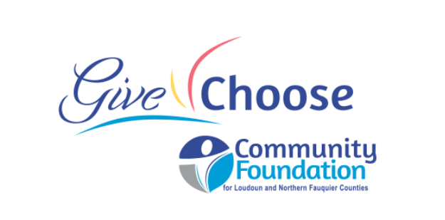
Give Choose
Statement of Agreement
Community Foundation for Loudoun and Northern Fauquier Counties
I wish to enroll my organization with GiveChoose.org to use as a fundraising vehicle and/or participate in our community’s annual day of online giving as hosted by the Community Foundation for Loudoun and Northern Fauquier Counties (hereafter “ Community Foundation”)
Name of organization:
Primary contact person:
Phone:
Email:
EIN/Tax ID*
*NOTE: Donor advised funds and fiscally sponsored programs are eligible to join in Give Choose. Your Tax ID number entered above should be their Tax ID. Do you have their express permission to participate in Give Choose? ________ Contact with fiscal sponsor or donor advised fund holder: _______________________
Does this nonprofit organization have or plan to have its own matching funds available for the giving day? Yes No (circle one). It is important that you notify Community Foundation staff of this amount as soon as you hear of matching funds! This will be added to your leader board during Give Choose (matching funds do not run through the Give Choose portal).
Is your organization headquartered or directly serving Loudoun County citizens? How many citizens in Loudoun County do you annually serve? ___________________________________
Is your organization headquartered or directly serving northern Fauquier County citizens. How many citizens in Fauquier County do you annually serve? ___________________________________
Annual Budget (circle one) $400,000 or LESS $401,000 or more
If your organization is accepted to participant in Give Choose, the Community Foundation will:
- Collect, process, and receipt donations from the public on your behalf.
- Provide your organization with access to the list of donors to your organization and their addresses, unless the donor has requested anonymity.
- Send a tax-qualified thank-you/follow-up email to all donors for their Give Choose gifts.

By signing this agreement, you certify that the named organization (hereafter “organization”):
- Is a 501 (c)(3) public charity in good standing with the Internal Revenue Service. If a current copy is not on file in the Community Foundation offices, a copy of your IRS letter of determination must be included with this signed agreement, or, you have express permission of your fiscal charitable sponsor to join the event under its Tax ID.
- Acknowledges agreement with the rules and guidelines for the website agrees to follow those rules and guidelines.
- Understand there are fees associated with Give Choose
- Agrees to submit an accurate organizational profile information for our nonprofit profile on the Give Choose website in a timely manner.
- Understands that the Community Foundation has final approval authority for all submitted information and may make changes to our profile after consultation with us.
- Agrees that the Community Foundation may collect, process, and receipt donations from the public on our behalf and that there are minimal fees associated with Give Choose.
- Acknowledges that the Community Foundation has exclusive legal control over all donations.
- Acknowledges organization may not provide goods or services in exchange for donations.
- Agrees that all organization donations will be for the benefit of the organization’s clients and programs specifically and limited to Loudoun and Fauquier Counties.
- Understands that the Community Foundation will have access to the list of organization donors and their contact information, unless the donor has requested anonymity.
- Acknowledges that the Community Foundation will send a tax-qualified thank-you/follow-up email to all donors as the formal tax substantiation of all gifts.
- Understands that organization shall thank its donors, but without gift amount or tax language.
- Understands that the Community Foundation does not make any explicit or implicit representation regarding the accuracy of the information contained in our organization’s profile.
- Understands that submitting a profile on the Give Choose website or this signed agreement does not constitute any assurance of funding by the Community Foundation.
- Upon request of the Community Foundation, may be required to provide a specific accounting of funds received for your organization
- Agrees that funds received shall not be used for political purposes.

The undersigned confirms they are authorized to act on behalf of grantee organization, affirms that all information presented is correct and with this signature seeks to participant in Give Choose:

For:_____________________________________________________________________________________
(organization name)

Signature Date

Printed Name Title

Give Choose Statement of Agreement must be received by the Community Foundation for Loudoun
and Northern Fauquier Counties

