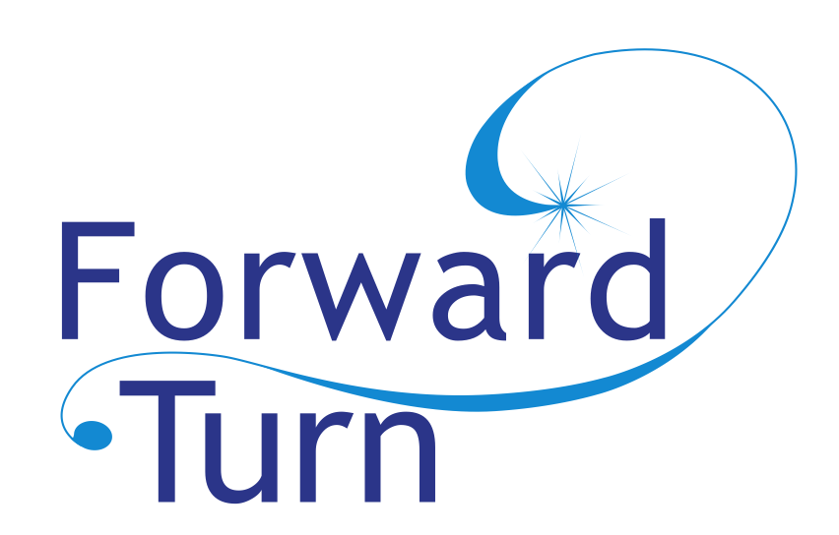

Community Foundation for Loudoun and Northern Fauquier Counties

Forward Turn Grant Application

S. Murray Rust and Mary H.C. Rust Student Philanthropy Project

Mission and Vision
Community Foundation for Loudoun and Northern Fauquier Counties was founded in 1999 to benefit the towns, countryside, and citizens of Loudoun and Fauquier Counties and surrounding areas. Grants from the Community Foundation are made possible by the generosity of donors who are committed to local philanthropy and our quality of life. Grants are recommended by varied fund committees and approved by the Community Foundation Board of Directors.

Forward Turn grants are advised by the Loudoun County Youth Advisory Council.

About the Forward Turn Donors: Children, grandchildren, and great-grandchildren of Stirling and Murray Rust and his wife Mary Hilton Coburn Rust seeded a permanent endowment, the S. Murray Rust and Mary H.C. Trust Student Philanthropy Project to create the Forward Turn Youth program.

Forward Turn Grant Guidelines ~ 2018 - 2019

The Community Foundation and its Forward Turn Youth Advisors will consider applications that Strengthen Positive Youth Lifestyle, Create United Youth Communities, and Encourage Community Youth Involvement in Loudoun and Fauquier Counties. We have a strong preference for youth involvement in the application process. See more about that below. Here are some ideas for grant programs, but we’re interested in your ideas, too:

- Address substance abuse and eating disorders in teens
- Educate teen users about internet safety
- Offer educational mentoring or tutoring programs for youth
- Teach tolerance and anti-bullying to teens
- Improve school attendance, reduce high-school dropout, and improve teen motivation
- Demonstrate road safety and safe driving practices
- Build meaningful links between youth, adults, and/or elderly
- Abate teen pregnancy
- Help with teen hunger, clothing, shelter, and poverty influences
- Bring awareness and helpful programs for teen depression and suicide
- Support programs that protect and preserve our environment

Grant-making Priorities
- Proposals written by teen applicants!
- Projects that include collaboration with another student, group, church, or charitable nonprofit
- Projects that leverage additional resources, like volunteer time, in-kind gifts of materials or supplies, or that are matched by other funding sources
- Ideas that have high impact with a small grant

Who is Eligible to Apply . . . and, Who receives the grant?
Forward Turn grant applicants may be faith groups, area charities, government groups, and schools (we cannot make a grant to an individual). We have a priority for grant proposals written by youth. However, the grant application may be written and prepared by an adult project leader, but we do require that a youth volunteer and program participant write a Letter of Endorsement and submitted with the grant application. For some quick summaries of past grants awarded, go to www.ForwardTurn.org.

Application Deadlines and Reviews
Applications must be submitted electronically via email on or before January 24, 2019. IMPORTANT: Applicants and the youth endorsing their work must be available for a face-to-face interview with Forward Turn youth grantmakers on the evening of February 11, from 6:00 PM-8:00 PM (we’ll work with you on the best time for you). Interviews will be at 20145 Ashbrook Pl #170, Ashburn, VA 20147.

Grant Size, Announcement, Final Reporting
Grants range from $500 to $1,500 (you must request a specific amount of funding). Grants will be announced no later than March 5, 2019. A final narrative report and summary of grant expenses must be provided to the Community Foundation by March 31, 2020. Extensions may be allowed but must be approved. Grant recipients have one year to complete a project once funded.

Application Instructions
Youth applicants should the following components:
- Application Cover Form
- A proposal or project summary, no more than three pages total. Help us clearly understand your program or project. In your narrative, be sure to explain:
  - What population will be served and what need will your project address?
  - Where will the project take place?
  - How many youth are involved in the project? What are their roles? List them.
  - Who are your project partners?
  - Do you have any experience with this project or similar projects? How did that go?
  - How will you publicize your grant and project outcomes?
  - Explain volunteer and staff involvement in your program
  - Will this project continue in the future? If so, how will it be funded? Include details about your project budget in your narrative, as needed.
  - What are the expected outcomes in your program? How will you define success?
- Include an additional page with a line-item budget for the program or project proposed (see attached). NOTE: Your income and expenses should equal. List other sources of funding pledged or received for your program or project; include donated materials and/or volunteer time.
- A one-page (longer is ok, too) Letter of Endorsement from a youth leader/volunteer/participant from your program. Be sure s/he (a) starts with a summary of the program (b) explains how they are involved in the program, and (c) shares their thoughts on how the program is positive and how it helps the community.

Support Materials—We need a copy of these four materials for the nonprofit you’re supporting; these materials aren’t necessary for a school or faith-based place of worship.
1. List of board of directors and their background 2. Most recent Form 990 or 990EZ 3. Most recent audit or financial statement 4. IRS letter of determination
Apply to:
amy@communityfoundationlf.org. For more information, call (703) 779-3505
Community Foundation for Loudoun and Northern Fauquier counties

2018-2019 Forward Turn Grant Application Cover Form

Project Title _________________________________________________________________________

Your Name ___________________________________ Your Phone ____________________________

Your Email ___________________________________Your Address ____________________________

Partner School/Church/Nonprofit _________________________________________________________

Partner Address _______________________________________________________________________
Partner Adult Sponsor or Agency Director Contact ___________________________________________
Adult E-mail ________________________________ Adult Phone ______________________________

Amount Requested $_______________

Check One: This proposal was written by ___ a youth (under 21) or ___ an adult
If adult, be sure to include a letter of recommendation for your project written by a youth

Proposal request summary (please use the space provided) ____________________________________
________________________________________________________________________________________________________________________________________________________________________
Total estimated number of youth directly aided in this program ____________
Total estimated number of youth participating in this program _____________

Which county will your project most benefit: Loudoun____ Fauquier____ Other ________
If “other” is checked, explain here: __________________________________________________

When will your program begin? __________________ End? ________________________________

If your partner is a charitable nonprofit, be sure to include:
IRS Letter of Determination ___ Form 990 or 990 EZ __
Annual Audit or Financial Statement __ Listing of Board of Directors __

Copies of this form should be placed on top of your proposal narrative along with the attached budget.

Be thoughtful about your budget submission. Our Youth Grantmakers often spend quite a lot of time scrutinizing your other income sources and project expenses. Many of our grant applicants have questions about preparing the budget. Feel free to call us at (703) 779-3505 to ask questions.

Forward Turn Program Budget PROJECT TITLE ______________________________________
Fill in or change all line items, providing descriptions for each line item, if you need to.

Expense Items | Budget
Equipment

Personnel Costs

Supplies

Transportation

Volunteer time (use the IRS figure of $24.69 per hour!)

Other

Total Expenses | $

Income Sources | Budget
Forward Turn Grant Amount Requested

Volunteer time (to get your budget to balance, it has to show up both as income & expense)

Other (explain)

Other (explain)

Total Income | $

Do your expenses equal your income? List other sources of funding. Tell us about them in your narrative.

