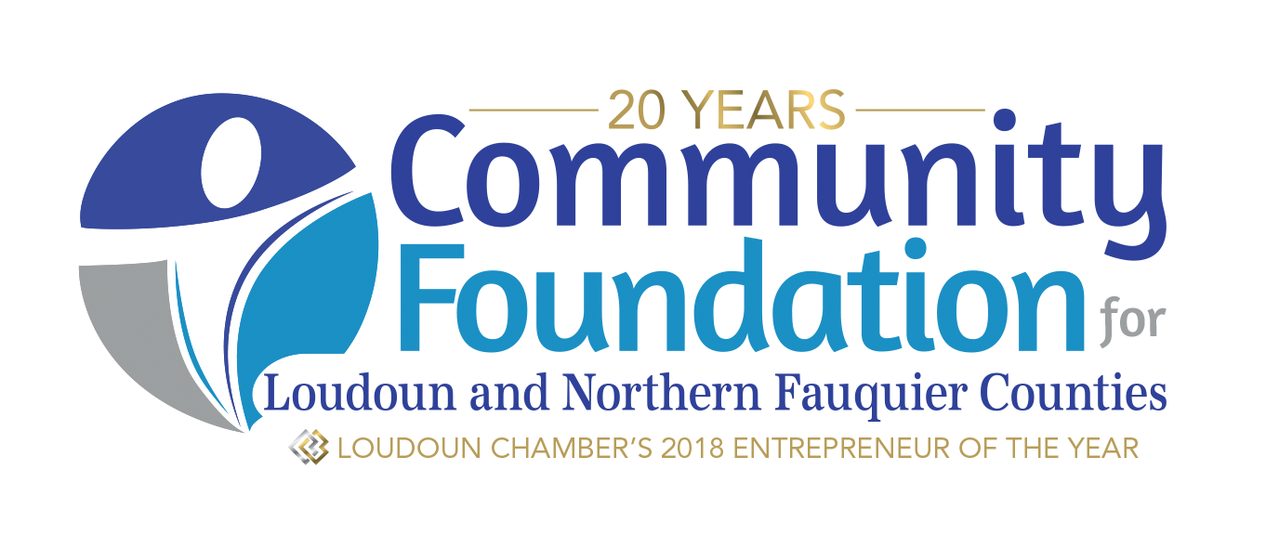

Platinum Achievement Award

Mission and Vision
The Community Foundation for Loudoun and Northern Fauquier Counties was founded in 1999 to benefit the towns, countryside, and citizens of Loudoun and Fauquier Counties and surrounding areas. Grants from the Community Foundation are made possible by the generosity of donors who are committed to local philanthropy and our quality of life. Grants are recommended by varied fund committees and approved by the Community Foundation Board of Directors.

About the Donors: The Platinum Achievement Award is made possible by donors who have made gifts to the Community Foundation inspired by and from the Faces of Loudoun website and community service campaign (FacesofLoudoun.org). Launched in 2017, the Faces of Loudoun campaign is designed to raise awareness about local needs facing Loudoun County, increase charitable giving and volunteerism, and celebrate local nonprofit leaders and volunteers.

Platinum Achievement Award ~ 2019
As the Community Foundation celebrates its 20th anniversary and 3rd year implementing the Faces of Loudoun campaign, we invite proposals for an inaugural Platinum Achievement Award. Three nonprofit organizations demonstrating significant internal innovation and improved operational achievement will be selected as recipients of a 2019 Platinum Achievement Award. In addition to being recognized as a nonprofit accomplishing significant achievement, each organization selected for this award will receive a $2,000 grant, courtesy of Faces of Loudoun donors, the Community Foundation, and Wells Fargo.

Eligibility Requirements:
Applicants must be a 501(c)(3) nonprofit public charity serving Loudoun County. Only one application per organization will be considered.

Grantmaking Priorities:
Nonprofit organizations founded and headquartered in Loudoun County will be a priority, with a history of mission delivery equal to or exceeding five-years. Awards will be made to organizations that have accomplished some or all of the following examples of innovation or achievement:
- Formulate, achieved or exceeded internal benchmarks or goals;
- devised systems to increased service delivery;
- established resources to add staff or new programing to address growing or unmet needs;
- taken steps to update or innovate data collection, software systems, or day-to-day operations; and/or
- incorporated new partnerships to strengthen results.

Application Deadlines and Reviews:
Applications must be submitted electronically via email to nicole@communityfoundationlf.org on or before Friday, April 26, 2019, midnight. Applicants will receive an email confirmation upon receipt of their application.

Grant Size, Announcement, Final Reporting:
Three grants of $2,000 each will be awarded. Applicants will be notified of final grant decisions by Friday, May 17, 2019. Awardees will be publicly announced and recognized during the Community Foundation’s Platinum Celebration event on Sunday, June 2, 2019; representatives from each awardee organization are requested to attend. In addition, awardees will be featured or included on the Community Foundation and Faces of Loudoun website, the Community Foundation Annual Report, annual Philanthropy Summit, and when possible, in additional marketing initiatives throughout the year. No final report is required for this grant.

Application Instructions
An application should include the following components:
- Application Cover Form
- Proposal (no more than three pages total)
  - Organizational Background—When founded, board composition, staffing and volunteer systems, and programmatic mission of the organization etc.
  - Organizational Milestones – Provide us with a timeline of your organization’s major milestones since its founding.
  - Statement of Achievement—Describe your organization’s major achievement(s) over the last five years. What challenges or obstacles were overcome? How has your organization used innovation, creativity, and/or best practices to accomplish this achievement? What is the impact of this achievement on your organization’s overall mission and work? How are the people and community you serve impacted by this achievement? How have you measured the outcomes of your organization’s major accomplishments and outcomes?
  - Share a single paragraph describing your organization’s vision for future achievements or advancements in the next five years.

Support Materials—Please provide a copy of the following materials, unless they are on file at

CFLNFC for your current fiscal year:
- List of board of directors and their background
- Most recent Form 990 or 990EZ
- Most recent audit, financial statement, or compilation
- IRS letter of determination
- Current Fiscal Year Organizational budget

Submit all application documents electronically via email by Friday, April 26, 2019 to:
Nicole Acosta; nicole@communityfoundationlf.org
Community Foundation for Loudoun and Northern Fauquier Counties
Subject Line: Platinum Achievement Awards

For more information or questions, call Nicole Acosta, Director of Grants and Nonprofit Programs at (703) 779-3505, ext 3
Platinum Achievement Award
COVER FORM ~ 2019

Organization _________________________________________________________________________

Mailing Address ______________________________________________________________________

___________________________________________________________________________________

Contact Name __________________________________ Contact Phone _________________________

Contact Title _____________________________Contact Email _______________________________

Title of Your Achievement: _____________________________________________________________

Summary of Organization Achievement (50 words or less):

____________________________________________________________________________________________________________________________________________________________________________________
____________________________________________________________________________________________________________________________________________________________________________________________________________________________________________________________________________

What percentage of your board make financial contributions to your organization? _____________

